Name:
Ahmed Mohamed Abdelhamed Fahmy Toto
ID: 320230110

Section: 3-AI

Supervisors:
Eng.Salma Waleed
and
Dr.Ahmed Anter

Aswan Solar Panel

Solar Power Output Prediction and Classification for Aswan Solar Panels Using Machine Learning and Statistical Analysis

Abstract
Solar energy is one of the most important renewable energy sources, especially in regions with high solar irradiance such as Aswan, Egypt. Accurate prediction and analysis of solar panel power output are essential for improving energy efficiency, planning, and decision-making. This project focuses on analyzing a real-world solar panel dataset collected from Aswan and applying mathematical, statistical, and machine learning techniques studied in the Mathematics for Data Science (AID311) course.
The project begins with an extensive preprocessing phase, including data visualization, missing value treatment, and statistical data analysis. Descriptive statistics such as mean, variance, standard deviation, skewness, and kurtosis are computed to understand data distribution. Inferential statistical methods, including correlation analysis, covariance matrix, heatmaps, t-tests, ANOVA, and chi-square tests, are applied to interpret relationships between variables.
Feature reduction and selection techniques such as Principal Component Analysis (PCA), Linear Discriminant Analysis (LDA), and Singular Value Decomposition (SVD) are implemented to reduce dimensionality while preserving important information. Multiple machine learning models are developed for both regression and classification tasks, including Linear Regression, Logistic Regression, K-Nearest Neighbors (KNN), Decision Tree, Naive Bayes, LDA classifier, and Neural Networks.
Model evaluation is performed using an 80% training and 20% testing split, along with K-fold cross-validation. Classification performance is assessed using confusion matrices, accuracy, precision, recall, F1-score, and ROC curves, while regression models are evaluated using MAE, RMSE, and R². Overfitting and underfitting are analyzed using learning curves. The results demonstrate that machine learning models can effectively predict and classify solar power output, providing valuable insights for renewable energy systems.

Introduction
With the increasing global demand for clean and sustainable energy, solar power has become a critical component of modern energy systems. Aswan is one of the most suitable locations for solar energy generation due to its high solar radiation levels throughout the year. However, solar power output is influenced by several environmental and operational factors, making accurate modeling a challenging task.
The main problem addressed in this project is predicting and analyzing solar panel power output using mathematical and machine learning techniques. This includes understanding the data behavior, reducing dimensionality, building predictive models, and evaluating their performance.
The techniques used in this project include statistical analysis, feature reduction methods (PCA, LDA, SVD), and supervised learning models for regression and classification. The main contribution of this project lies in integrating mathematical analysis with machine learning models and providing a complete evaluation framework following the AID311 course requirements.
The rest of this documentation is organized as follows: Section 3 presents related work, Section 4 describes the methodology, Section 5 explains the proposed model, Section 6 discusses the results, and Section 7 concludes the project with future work directions.

Related Work
Several studies have addressed solar energy prediction using statistical and machine learning techniques. Table 1 summarizes selected related work.
References
Reference | Year | Methods Used | Key Results
AlKandari & Ahmad | 2024 | Ensemble DL + Statistical Models | Improved forecasting accuracy
Ledmaoui et al. | 2023 | ML algorithm comparison | ML outperformed traditional models
Pourmir & Miri | 2025 | ML + Statistical Tests | Statistically significant model differences
Jebli et al. | 2021 | Pearson correlation + ML | Feature selection improved accuracy

Methodology
This project follows a structured methodology:
- Data collection and understanding
- Data preprocessing and visualization
- Statistical data analysis
- Feature reduction and selection
- Model implementation (classification and regression)
- Model evaluation and validation
- Result interpretation
Each phase is implemented using Python and scientific libraries such as NumPy, Pandas, Matplotlib, Seaborn, and Scikit-learn.

Proposed Model
The proposed model consists of the following phases:
1. Preprocessing
- Data visualization
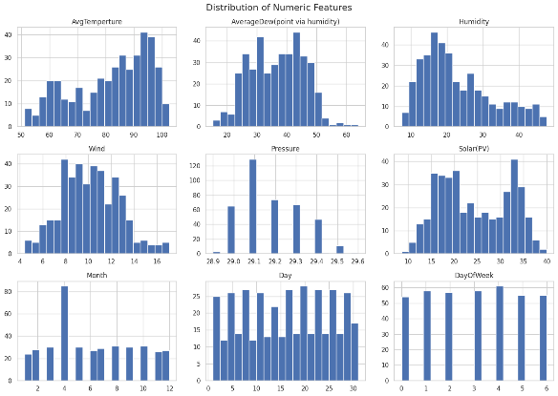
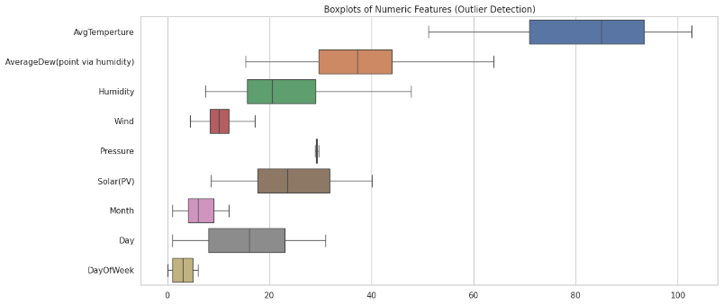
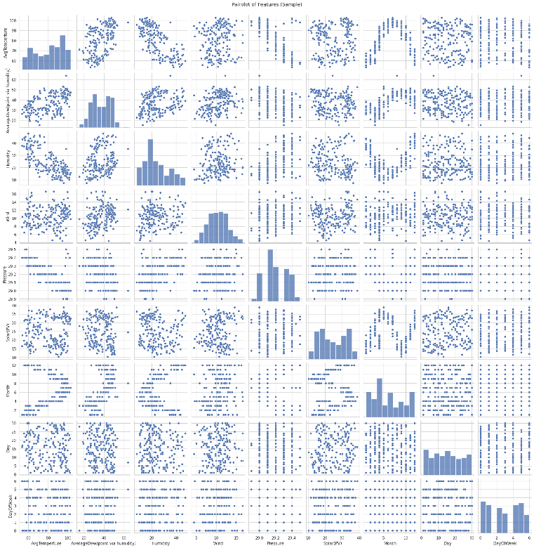
- Missing value treatment
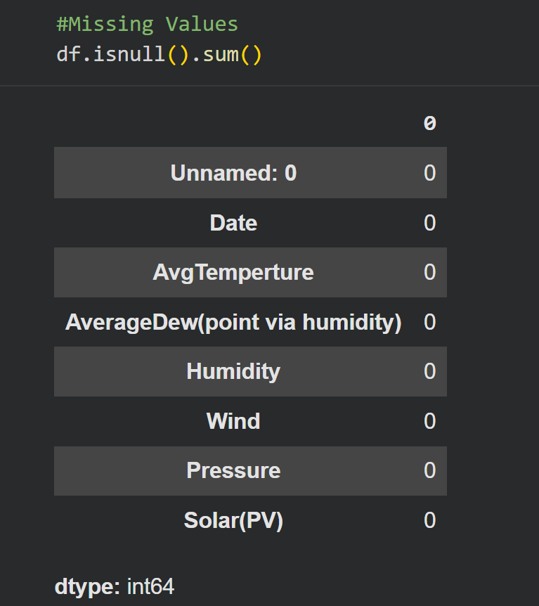
- Binning (if applicable)
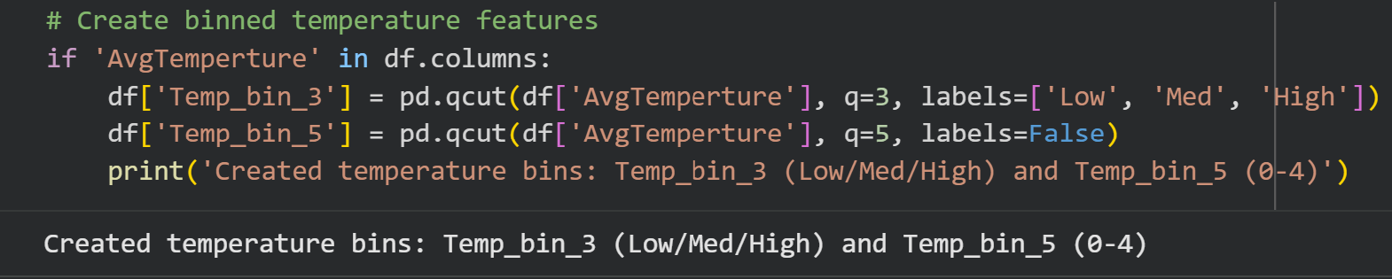
- Descriptive statistics
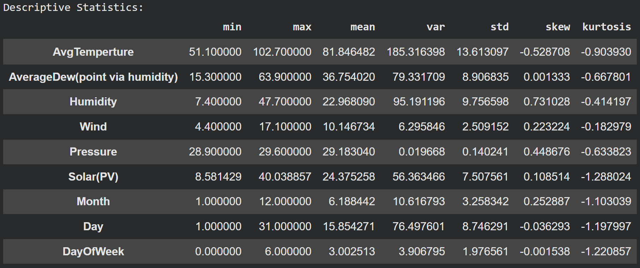
- Correlation and covariance analysis
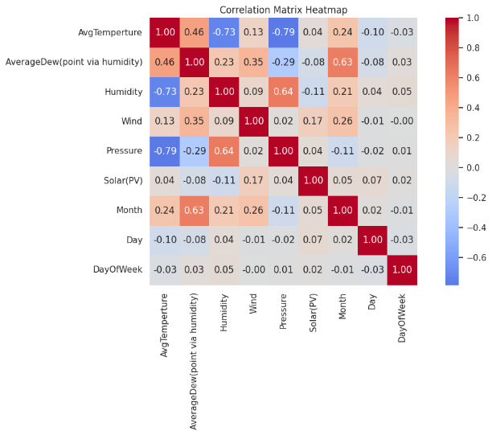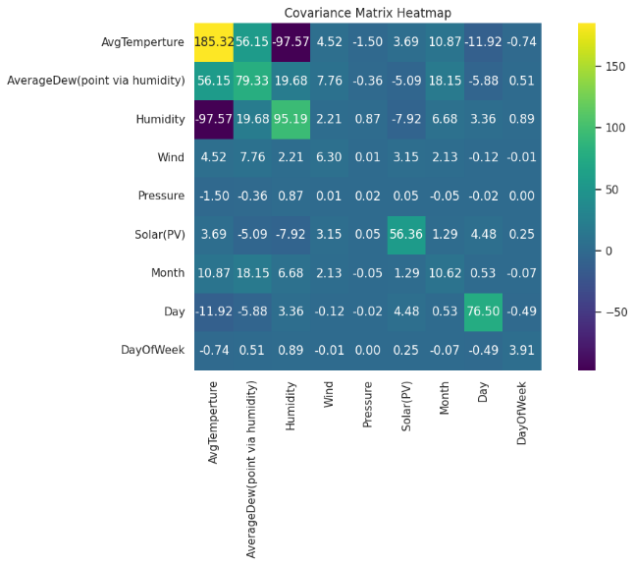

- Statistical hypothesis testing
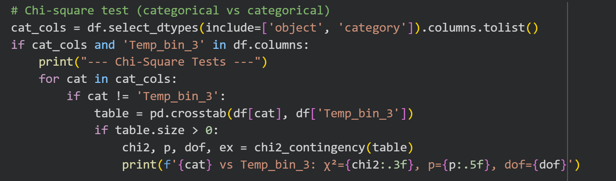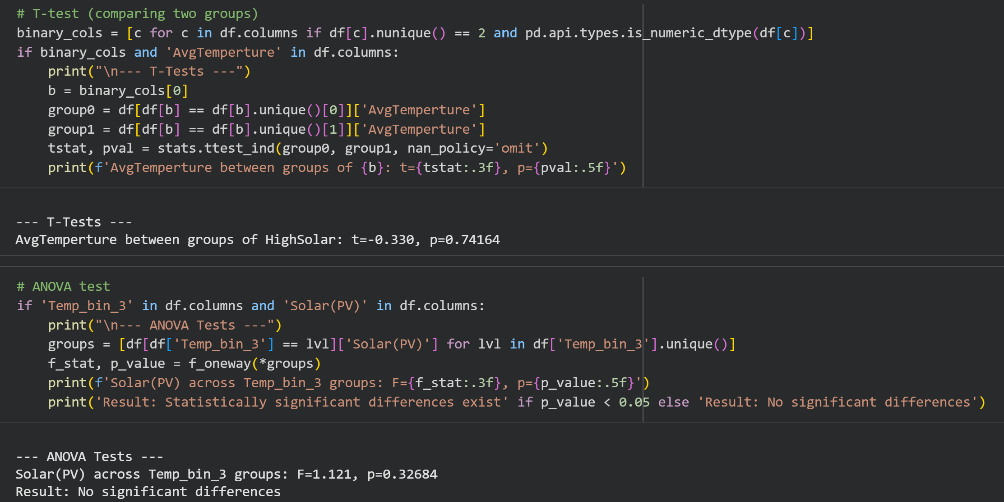

2. Feature Reduction
- Principal Component Analysis (PCA)
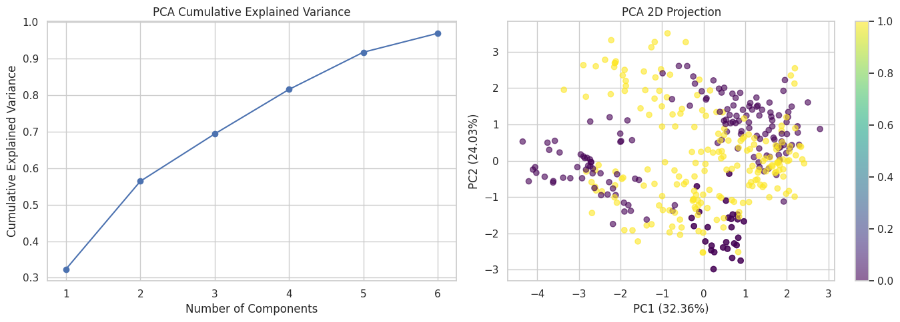
- Linear Discriminant Analysis (LDA)
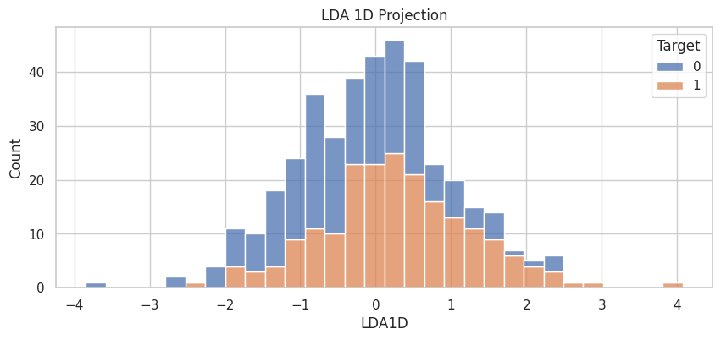
- Singular Value Decomposition (SVD)
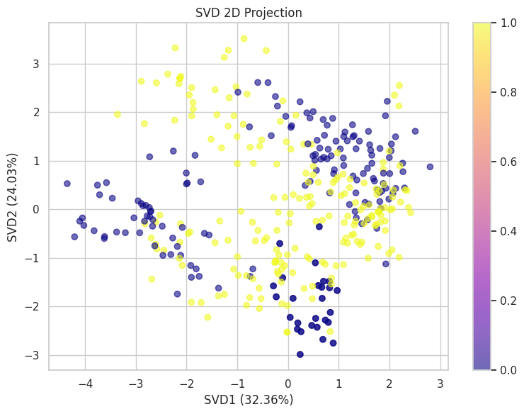
3. Classification and Regression Models
- Linear Regression
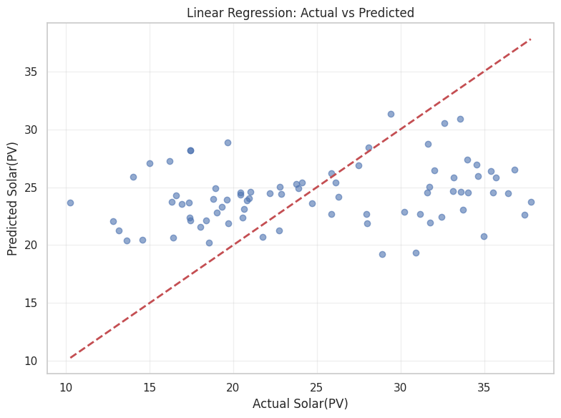
- Logistic Regression
- K-Nearest Neighbors (KNN)
- Decision Tree
- Naive Bayes
- LDA Classifier
- Neural Network (Feed Forward & Backpropagation)
4. Evaluation Metrics
- Train-test split (80/20)
- K-Fold cross-validation
- Classification metrics (Confusion Matrix, Accuracy, Precision, Recall, F1, ROC)
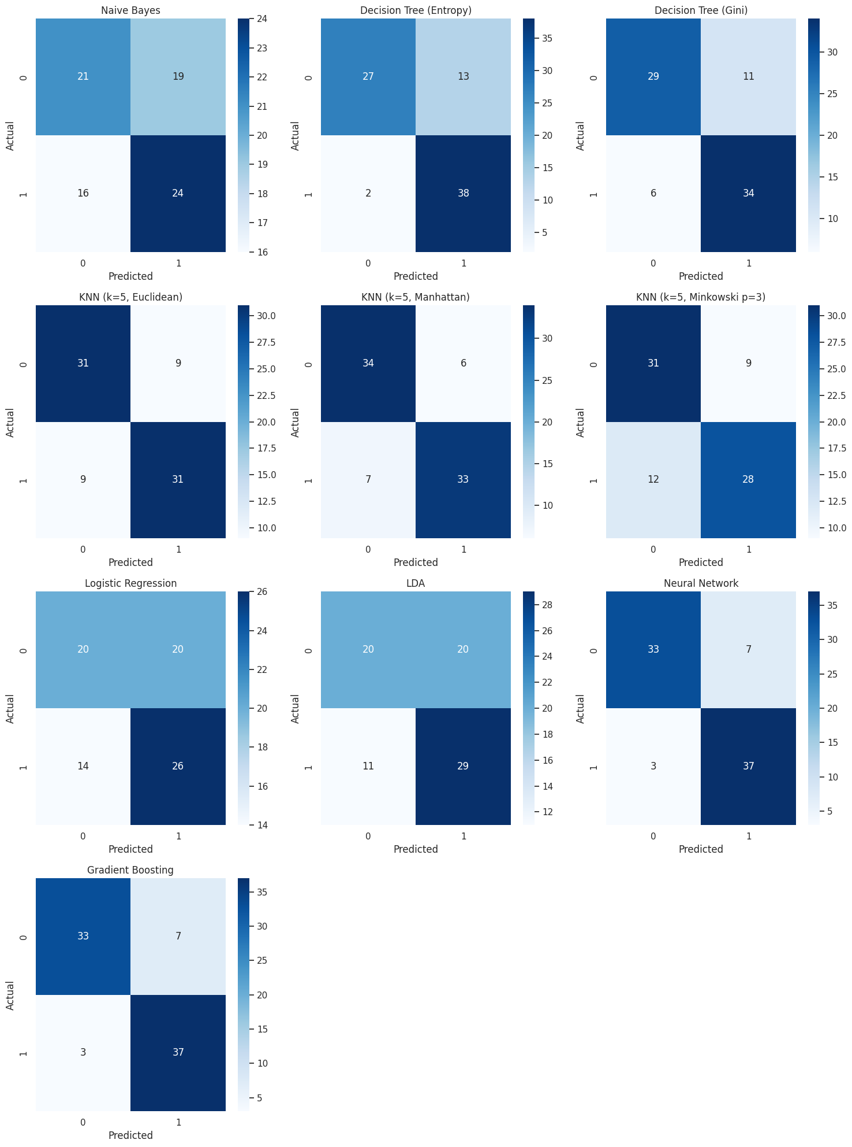
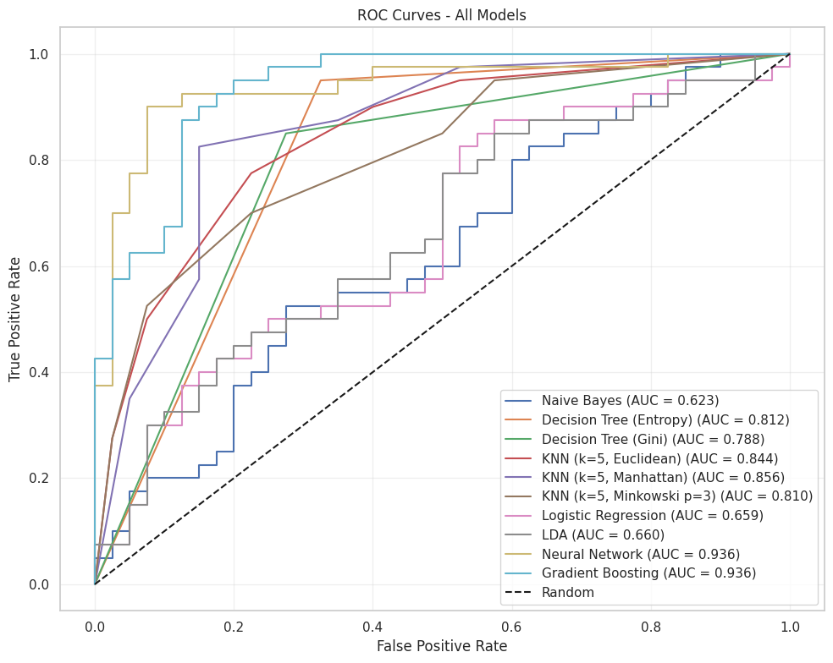
- Regression metrics (MAE, RMSE, R²)

Results and Discussion
Dataset Description
The dataset contains solar panel measurements collected from Aswan, including environmental and operational features related to power generation.
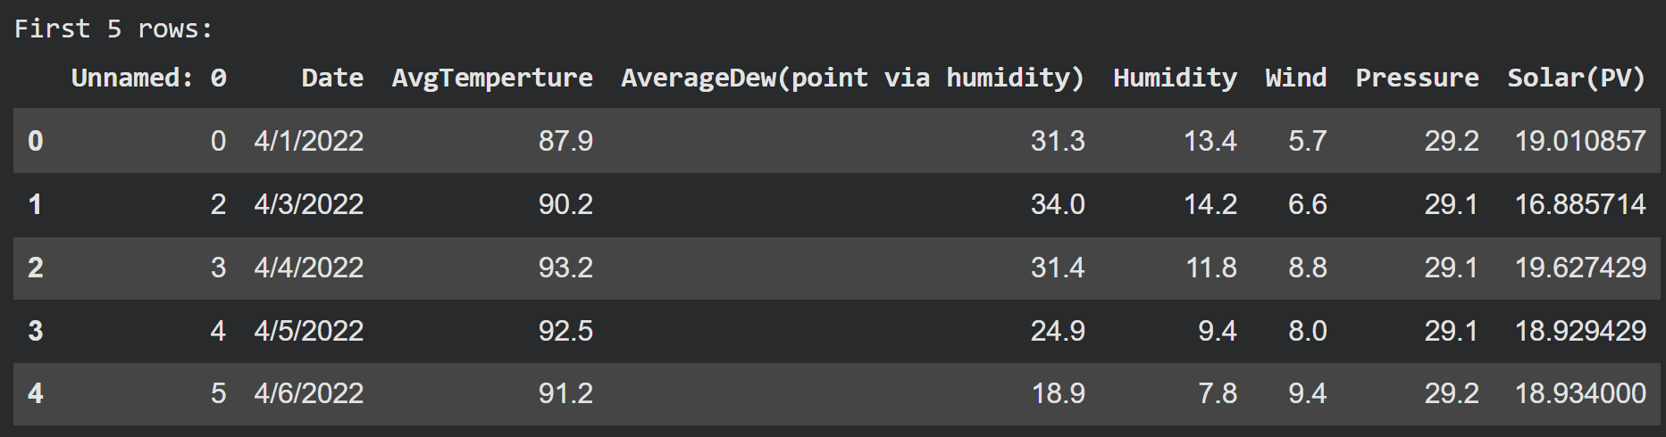
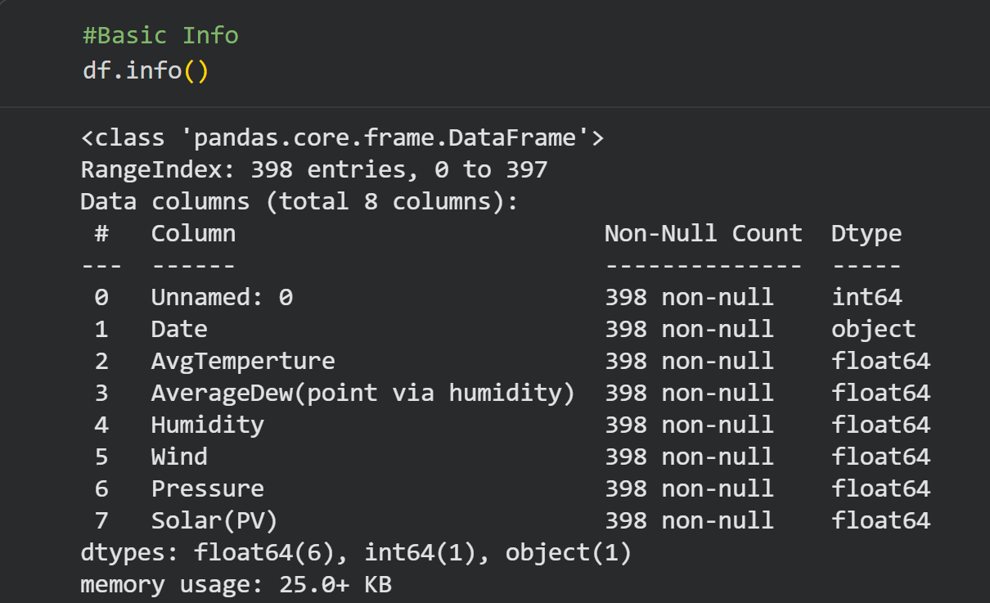
Preprocessing Results
- Visualization revealed data distribution and outliers
- Missing values were treated appropriately
- Statistical measures (mean, variance, skewness, kurtosis) provided insight into data behavior
- Correlation analysis identified key relationships
- Hypothesis tests validated statistical significance
Feature Reduction Results
- PCA reduced dimensionality while retaining variance
- LDA improved class separability
- SVD efficiently captured latent structure
Model Performance
Regression and classification models were evaluated and compared using tables and figures. Neural Networks and ensemble-based approaches achieved strong performance, while linear models provided interpretability.
Overfitting and Underfitting
Learning curves were analyzed to detect overfitting and underfitting. Appropriate model complexity and validation strategies were applied.
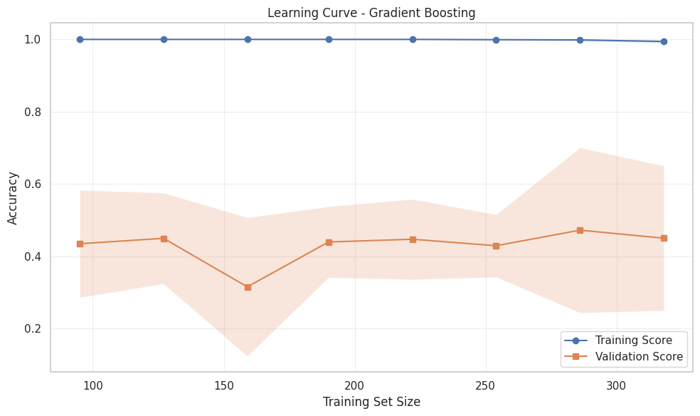
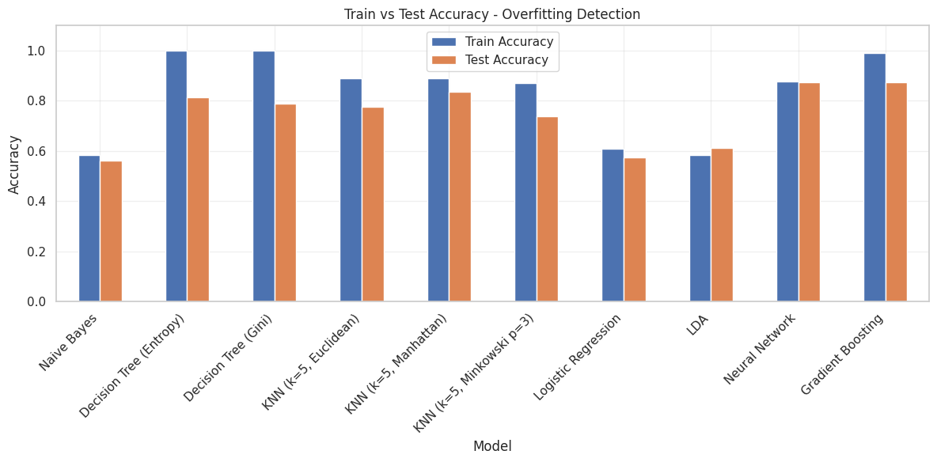

Conclusion and Future Work
This project demonstrated the effectiveness of combining mathematical analysis with machine learning techniques for solar power prediction. The results show that proper preprocessing, feature reduction, and model evaluation significantly improve performance.
Future work may include applying deep learning models, incorporating additional environmental data, and testing the models on different geographical datasets to improve generalization.

References
  - Tiberiu Tudorache, Liviu Kreindler “Design of a Solar Tracker System for PV Power Plants,” Acta Polytechnica Hungarica, vol. 7, no. 1, pp. 23 39, 2010.

  - M. Abuella and B. Chowdhury, “Solar Power Probabilistic Forecasting by Using Multiple Linear Regression Analysis,” in IEEE Southeast conference Proceedings, Ft.Lauderdale, FL, 2015.

  - J. Zeng and W. Qiao, "Short-term solar power prediction using an RBF neural network," 2011 IEEE Power and Energy Society General Meeting, Detroit, MI, USA, 2011, pp. 1-8, doi: 10.1109/PES.2011.6039204.

  - Kosmopoulos, P.G.; Kazadzis, S.; El-Askary, H.; Taylor, M.; Gkikas, A.; Proestakis, E.; Kontoes, C.; El-Khayat, M.M. Earth-Observation-Based Estimation and Forecasting of Particulate Matter Impact on Solar Energy in Egypt. Remote Sens. 2018, 10, 1870. https://doi.org/10.3390/rs10121870

